Disney Movies Data Visualization

**Dataset Description**

The dataset I have chosen for this project is the [Disney Movies (1937-2016) Gross Income](https://www.kaggle.com/datasets/rashikrahmanpritom/disney-movies-19372016-total-gross) dataset sourced from Kaggle. As the name suggests, this dataset contains data on 579 Disney movies released from 1937 to 2016.

Data attributes:

* movie_title
* release_date
* genre
* mpaa_rating
* total_gross
* inflation_adjusted_gross

**Compelling Story**

The Walt Disney Studios is an American entertainment studio founded in 1923 that has since released six of the top ten highest-grossing films of all time. Due to a recent decline in viewership, the bigwigs at Disney would like to look into the company’s historic box office data to derive actional insights with regards to replicating previous successes.

It is up to us to analyze the provided dataset and to create meaningful visualizations that will help communicate discovered patterns to our superiors.

**Audience**

Our primary audience/stakeholders include Disney executives inquiring about the company’s historic box office performance.

**Questions**

1. What were the top 15 highest grossing films? *Plot 1*
2. Which year(s) saw the highest gross income? *Plot 2*
3. Which genre(s) generated the highest gross income? *Plot 3*

**Layout**



Movies

(1937 – 2016)

Text (dataset information, background information, audience, etc.)

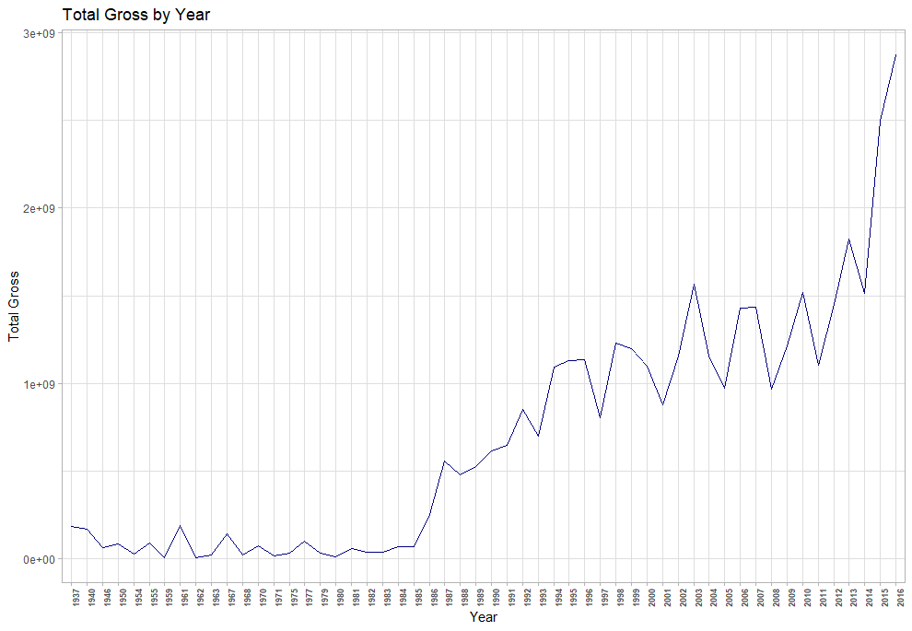

Text (cont.) Plot 2

(multi-dimensional plot with inflation)

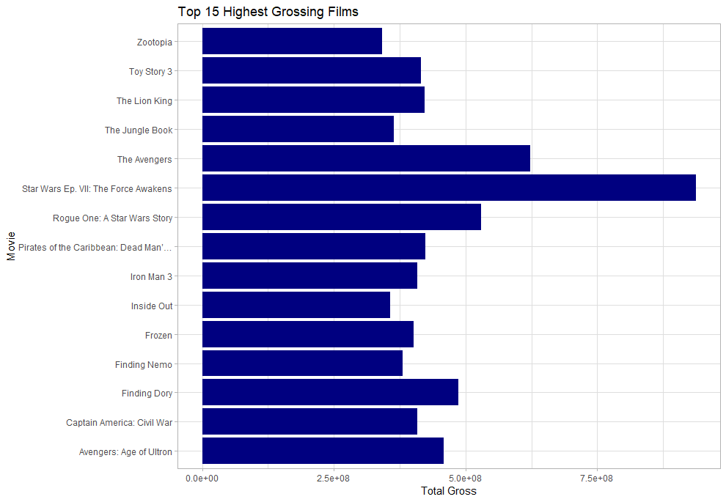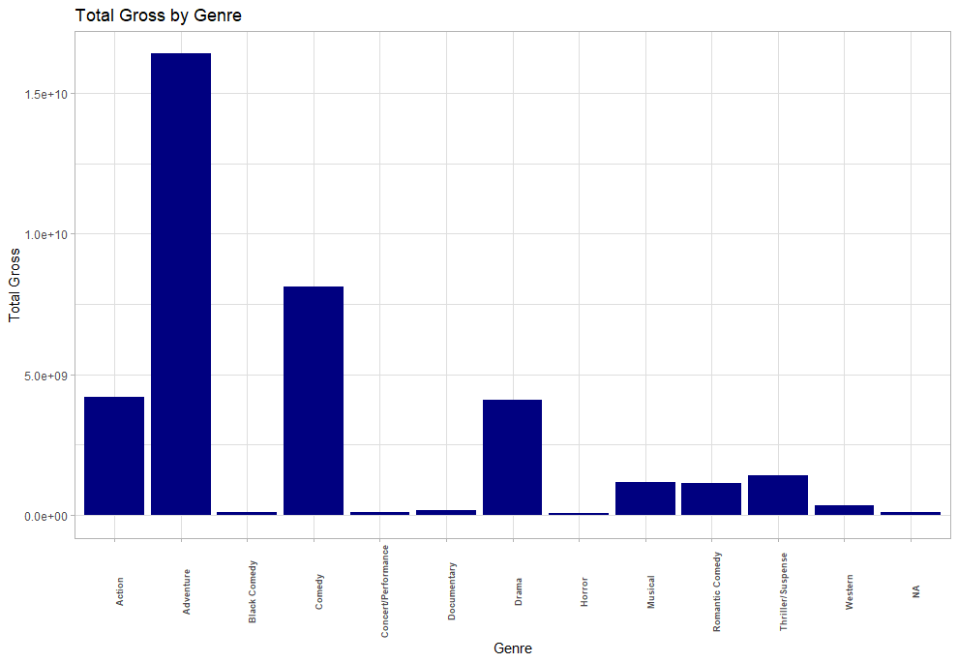

Plot 1 Plot 3

**Plot 1**



**Plot 2**



**Plot 3**

